Year 4 Spring 1 KIRF
Multiplication and division facts for the 9 and 11 times table
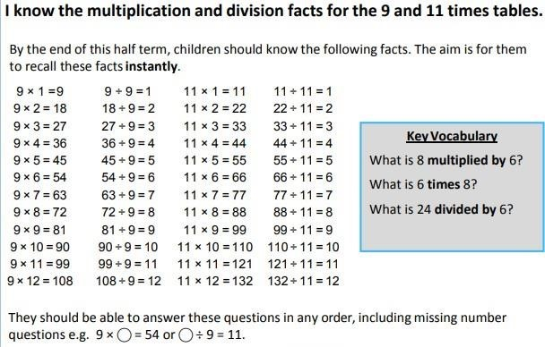

Top Tips
The secret to success is practising little and often. Use time wisely. Can you practise these KIRFs while walking to school or during a car journey? You don’t need to practise them all at once: perhaps you could have a fact family of the day. If you would like more ideas, please speak to your child’s teacher.

Look for patterns – These times tables are full of patterns for your child to find. How many can they spot? Use your ten times table – Multiply a number by 10 and subtract the original number (e.g. 7 × 10 – 7 = 70 – 7 = 63). What do you notice? What happens if you add your original number instead? (e.g. 7 × 10 + 7 = 70 + 7 = 77)
What do you already know? – Your child will already know many of these facts from the 2, 3, 4, 5, 6, 8 and 10 times tables. It might be worth practising these again!

